Sales Performance vs. Target

* Created Dashboard using Sample – Superstore and Sales Target Extract data
* Created Bullet Dashboard showing Sales vs. Target Sales with filters by Year and Sales Target (Above/Below)
* Added colors by Sales budget(Above/Below target)

Final Dashboard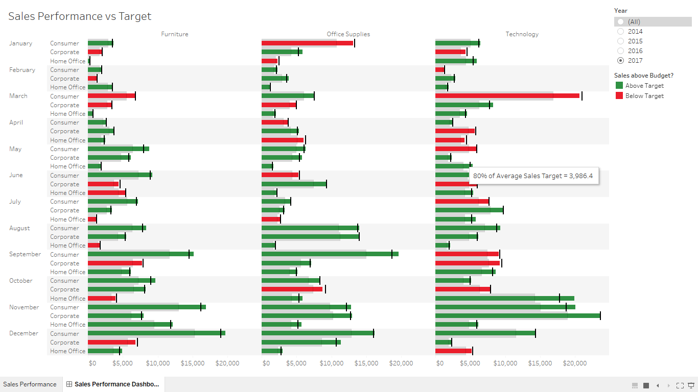

Worksheet

